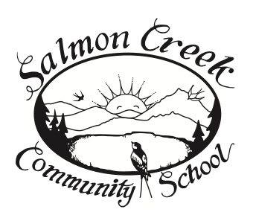
P.O. Box 670, Miranda, CA. 95553
call 707-943-1500 or
call/text 707-602-7722

EVENT FORM for activities on school property
Salmon Creek Community School grounds are available for activities that promote community interaction, education, health and safety.
Event: ___________________________________________________________________________
Purpose:__________________________________________________________________________
__________________________________________________________________________________
__________________________________________________________________________________
Organizers are responsible for returning site to original condition.
Organizer(s) and contact information:
_________________________________________________________________________________
_________________________________________________________________________________
Date(s) and Times of Operation:______________________________________________________
Donation to school?:________________________________________________________________
What is needed from the school (Building(s), power, water, fuel, etc.):__________________________________
____________________________________________________________________________________________________________
____________________________________________________________________________________________________________
__________________________________________________________________________________

Board member signature for approval: ________________________________________________
Waiver of Liability and Assumption of Risk Agreement Use of Premises
Waiver: In consideration of my use of the premises of Salmon Creek Community School, I for myself, my heirs, personal representative or assigns, do hereby release, waive, discharge, and covenant not to sue Salmon Creek Community School, it’s trustees, directors, officers, employees and agents from liability from any and all claims including negligence resulting in personal injury, accidents, or illnesses (including death) and property loss arising from use of premises.
Assumption of Risk: In acknowledgment that the activity described on this event form carries with it certain inherent risks that cannot be eliminated regardless of the care taken to avoid injuries. I have read the previous paragraphs and I know and understand and appreciate these and other risks are inherent in the activity I am participating in. I hereby assert that my participation is voluntary and that I knowingly assume all such risks.
Indemnification and Hold Harmless: I also agree to indemnify and hold harmless Salmon Creek Community School, its trustees, directors, officers, employees and agents from any and all claims, actions, suits, costs, expenses, damages and liabilities including attorney fees as a result of this use of premises.
Severability: The undersigned further expressly agrees that the forgoing waiver and assumption of risk agreement is intended to be as broad and inclusive as is permitted by the law of the State of California and that if any portion thereof is held invalid, it is agreed that the balance shall, notwithstanding, continue in full legal force and effect.
Acknowledgement of Understanding: I have read this waiver of liability, assumption of risk, and indemnity agreement, and fully understand its terms. I acknowledge that I am signing the agreement freely and voluntarily, and intend by my signature to be a complete and unconditional release of all liability to the greatest extent allowed by law.
Signature of Participant & Date:_______________________________________________________

